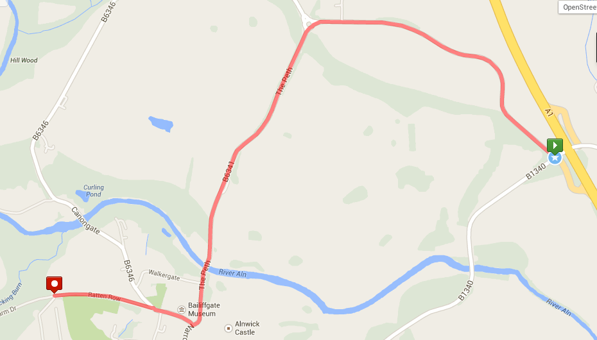

LES ALLCORN FUN RUN & 10K DIRECTIONS

FREE OFFICIAL RACE PARKING

LES ALLCORN

START, FINISH & RACE REGISTRATION

DUCHESS

HIGH SCHOOL

SEE ‘LES ALLCORN PARKING’ FOR FURTHER DETAILS & OVERFLOW PARKING

**Ratten Row**

2ND EXIT FROM A1, HEADING NORTH OR SOUTH, SIGNED DENWICK & ALNWICK GARDENS, THEN FOLLOW ALNWICK HARRIERS EVENT SIGNAGE.

**LES ALLCORN FUN RUN & 10KM**

Hulne Park Entrance

Ratten Row

Alnwick

Northumberland

NE66 2LL